**M.I.T. LAB Assignment – 03**

**U19CS012**

(1) Write a program to load the data byte A8H in register C. Mask the high-order

Bits (D7-D4), and display the low-order bits (D3-D0) at an output port.

Notepad Code:

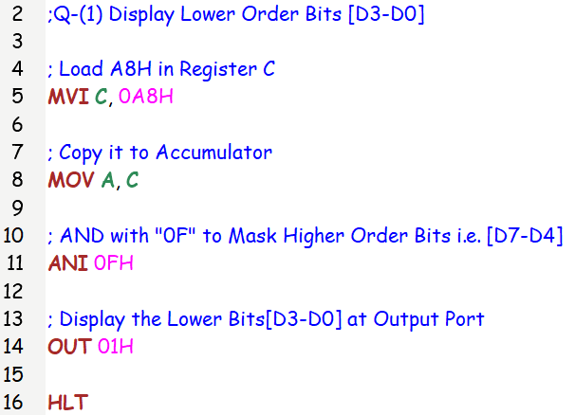

Registers and Memory:

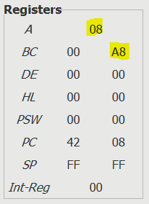 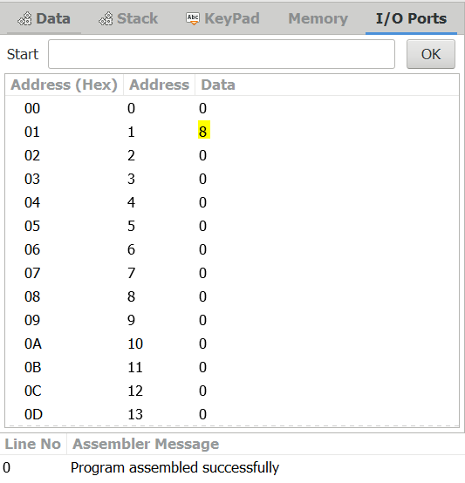

(2) Write a program to load the data byte 8EH in register D and F7H in register

E. Mask the high-order bits (D7-D4) from both the data bytes, Exclusive-OR the low-order bits (D3-D0) and display the answer.

Notepad Code:

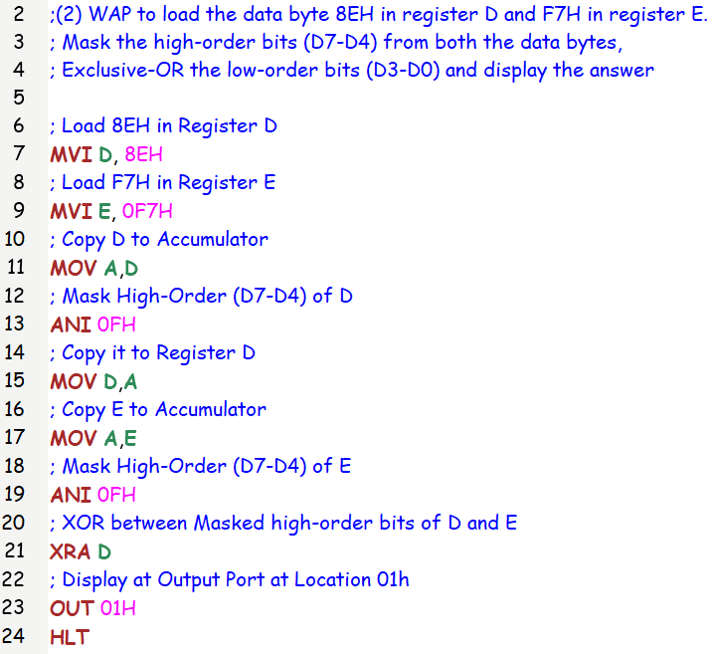

Registers and Memory: XOR ((1110) ^ (0111)) = (1001) = 9

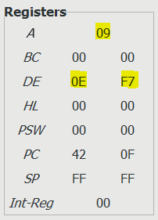 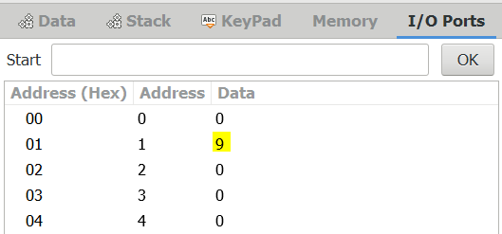

(3) Write a program to load the bit pattern 91H in register B and 87H in register

C. Mask all the bits except D0 from registers B and C.

Notepad Code:

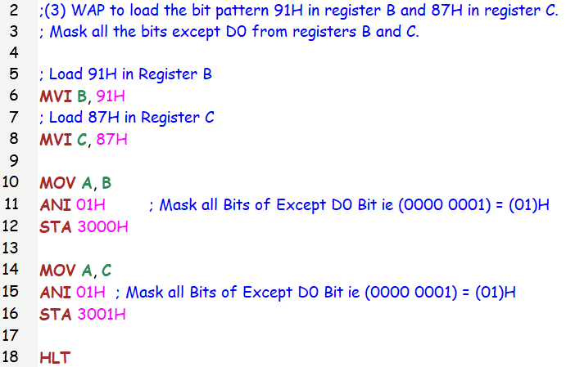

Registers and Memory:

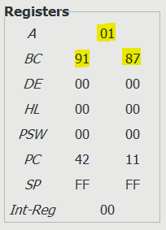 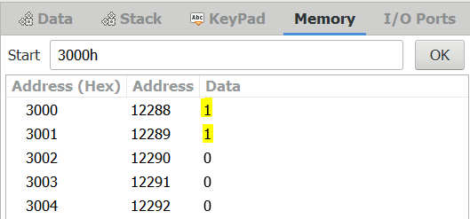

(4) Write a program to clear the CY flag, to load number FFH in register B, and increment B. If the CY flag is set, display 01 at the output port, otherwise, display the contents of register B.

Notepad Code:

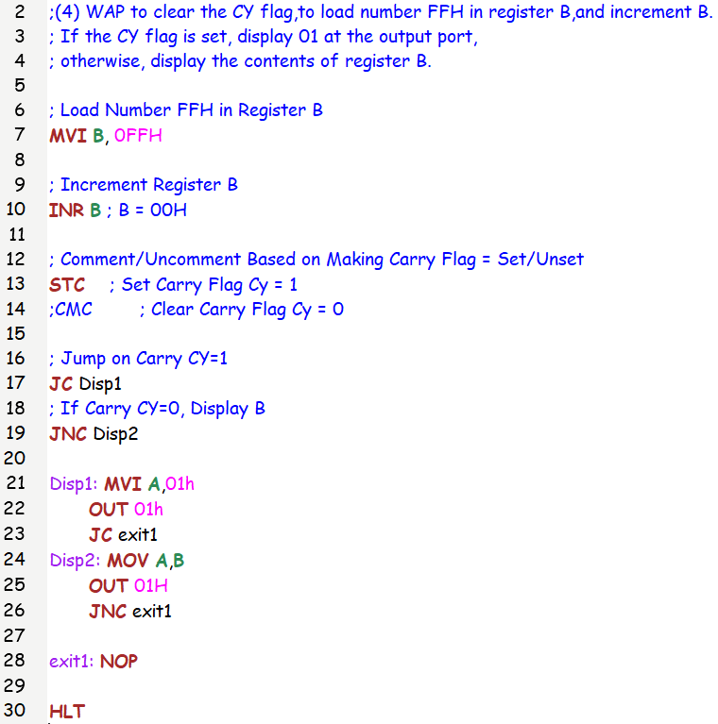

Registers and Memory:

(1) Flag is Set (Cy=1)

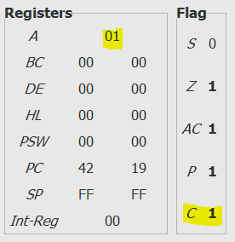 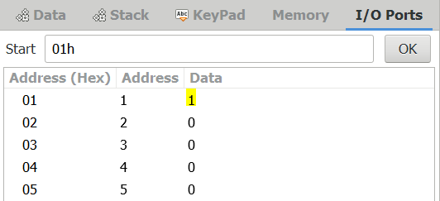

(2) Flag is Not Set (Cy=0)

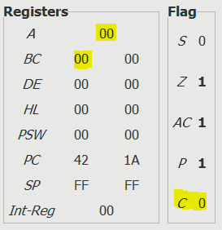 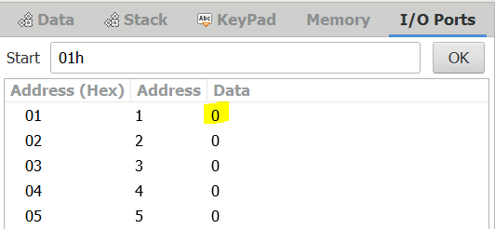

(5) Write a program to mask lower bit of an 8-bit number.

Notepad Code:

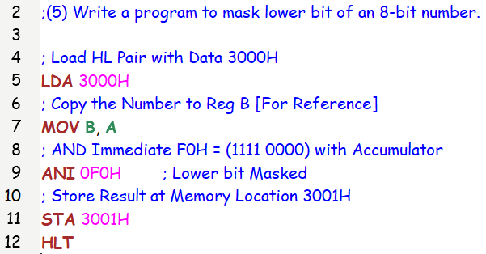

Registers and Memory:

Input: 135 = (87)H

Output: (87^(1111 0000))H = (80)H = 128

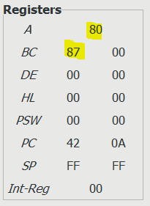 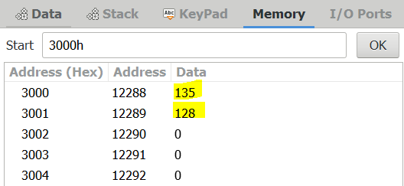

(6) Write a program Load two unsigned numbers in register B and register C, respectively. Subtract C from B.

If the result is in 2’s complement, convert the result in absolute magnitude and display it at PORT 1, otherwise, display the positive result.

Execute the program with the following sets of data.

Notepad Code:

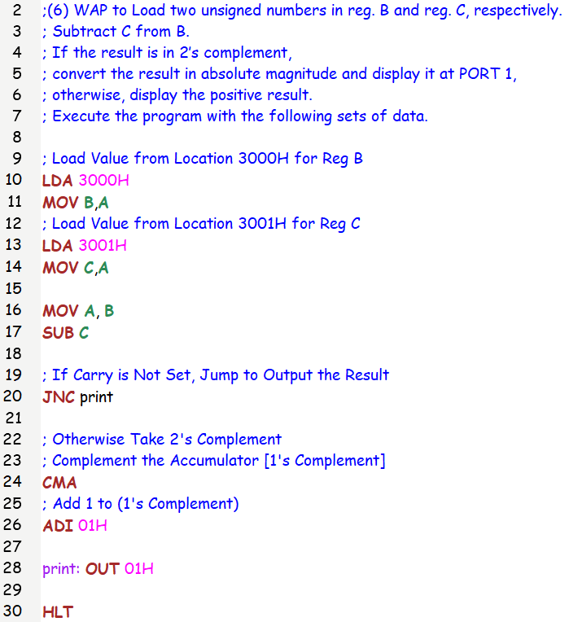

Set1: B=42H -> 66, C=69H -> 105

Output: absolute(66-105) = 39 = (27)H

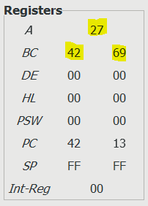 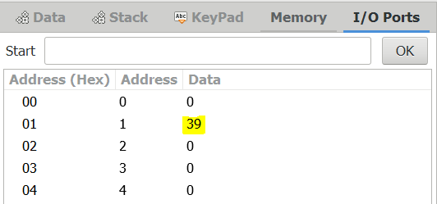

Set2: B=69H -> 105, C=42H -> 66

Output: absolute(105-66) = 39 = (27)H

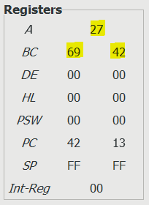 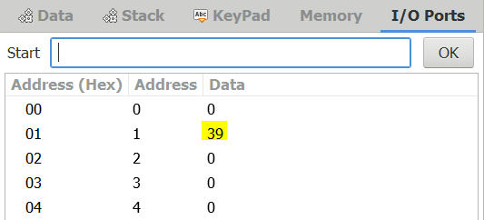

Set3: B=F8H -> 248, C = 23H –> 35

Output: absolute(248-35) = 213

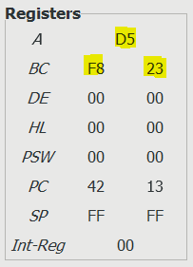 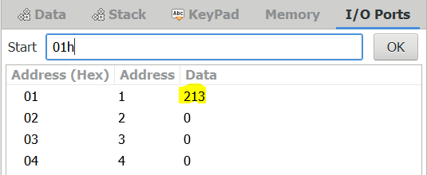

SUBMITTED BY: BHAGYA VINOD RANA [***U19CS012***]